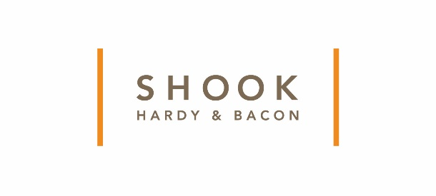
Shook Eight-Time WILEF Honor Reinforces Firm Culture
Shook is one of only two law firms nationally to meet all criteria since the WILEF award began in 2011.
Kansas City, Mo (July 2, 2018) For the eighth consecutive year, Shook, Hardy & Bacon L.L.P has been awarded the 2018 Gold Standard Certification from the Women in Law Empowerment Forum (WILEF). The Gold Standard Certification measures the progress law firms are making with integrating women into leadership roles. Shook is one of only two firms to meet all the criteria requirements since the award’s inception in 2011.
“We live and breathe it every day in the culture we create which allows us to effectively collaborate to best serve our clients,” said Shook Chair Madeleine McDonough. “It’s an honor to be recognized for being at the forefront of diversity and inclusion.”
Shook is one of only 12 firms that have been awarded a Gold Standard every year since the award’s inception in 2011. In order to receive the WILEF certification, firms with 300 or more practicing lawyers in the United States must meet at least four of the following criteria. Shook met all the criteria.
- 20 percent of U.S. equity partners, or, alternatively, one-third of attorneys who became U.S. equity partners within the previous 12 months, are women;
- 15 percent of the heads of the firm and its U.S. branch office heads combined are women;
- 20 percent of the members of the firm’s primary governance committee are women;
- 20 percent of the members of the committee that determines equity partner compensation are women;
- 25 percent of U.S. practice group leaders/department heads are women;
- 15 percent of the top half of U.S. equity partners in terms of compensation are women; and
- 7 percent of U.S. women equity partners are women of color and/or 3.5 percent of them are LGBT.
“We consistently reevaluate and improve our best practices to create an inclusive firm and support our talent to thrive which is vital for our success,” said Shook’s Director of Strategic Diversity Initiatives Kori Carew. “Earning this recognition, eight years consecutively in all areas, is an accomplishment all of us at Shook can celebrate together.”
The firm has recently been recognized for its diversity and inclusion achievements in the following:
- The Coca-Cola Company, 2017 General Counsel Diversity Advancement Award. The Coca Cola Company also awarded Shook its “Living the Values” award three times, twice in the last five years.
- Human Rights Campaign, Corporate Equality Index, a perfect score of 100% for ten consecutive years.
- Working Mother Magazine, “50 Best Law Firms for Women” for several years.
- Vault, “Best Law Firms for Overall Diversity” and ranked in the Top 25 firms for diversity for minorities, diversity for women, and diversity for LGBT employees several years in a row.
- Law360 Glass Ceiling Report ranked Shook in Top Three “Best Law Firms for Women” and a “Ceiling Smasher” for women equity partnership representation, 300 to 599 lawyers. (2015-2018)
About WILEF
WILEF is the premier organization for women from large law firms and corporate law departments in the United States. The Gold Standard Certification, launched in 2011, recognizes firms with meaningful percentages of women in leadership roles, rather than the policies or practices of the firm or the overall number or percentage of women in the partnership. www.wilef.com.

About Shook, Hardy & Bacon
Founded in 1889, Shook, Hardy & Bacon L.L.P. has 12 offices in the United States and London, with attorneys and professional staff serving clients in the health, science and technology sectors in areas ranging from product liability defense and commercial litigation to intellectual property prosecution and litigation, environmental and toxic tort, privacy and data security, and regulatory counseling.

